PRESS RELEASE
FOR IMMEDIATE RELEASE

Distinguished Designers Assemble in Hong Kong to Celebrate Design Excellence at
DFA Awards 2024 - Presentation Ceremony

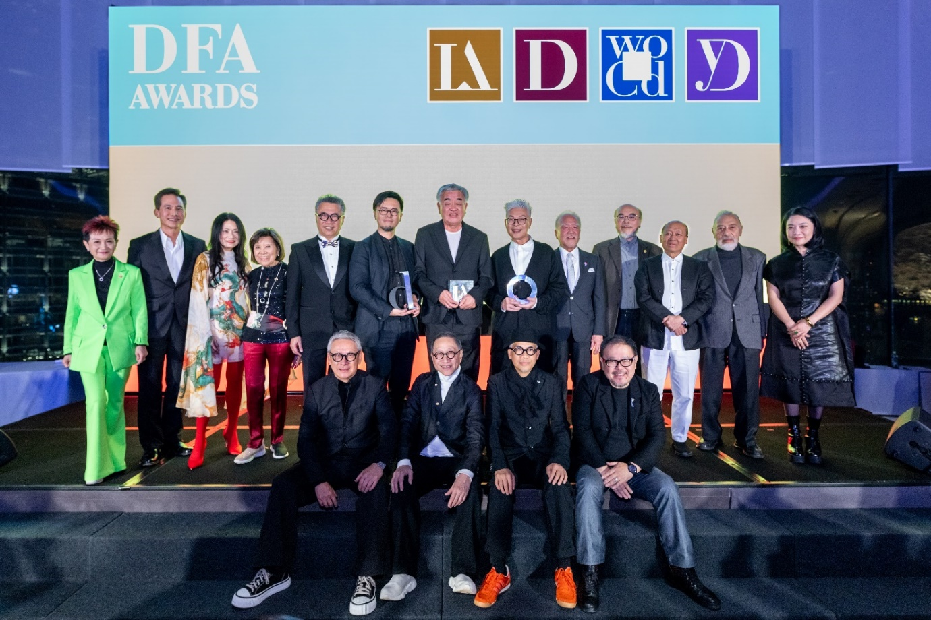
(at the back, from left) Prof. Viveca CHAN, Vice Chairman of HKDC, Mr. Anthony LO (DFA WOCD 2012), Ms. Vivienne TAM (DFA WOCD 2005), Ms. Kai-Yin LO (DFA WOCD 2007), Prof. Eric YIM, Chairman of HKDC, Mr. Eisuke TACHIKAWA (DFA DOY 2024), Mr. Kengo KUMA (DFA LAA 2024), Mr. Tino KWAN (DFA WOCD 2024), Mr. Junzo TATENO, President of Union Corporation Japan, Mr. Victor LO (DFA DLA 2023), Mr. Chi Wing LO (DFA WOCD 2015), Dr. Henry STEINER (DFA LAA 2012), Ms. GUO Pei (DFA WOCD 2022)

(at the front, from left) Mr. Steve LEUNG, Vice Chairman of HKDC, Mr. Alan CHAN (DFA WOCD 2017), Mr. Stanley WONG (DFA WOCD 2020), Mr. Freeman LAU (DFA WOCD 2021)

(HONG KONG, 9 December, 2024) The DFA Awards 2024, organised by the Hong Kong Design Centre with the Cultural and Creative Industries Development Agency as the lead sponsor, concluded at its prestigious awards ceremony. Recognising and celebrating design excellence and innovation for Asia, global design luminaries and design leaders gathered to commemorate and showcase the exceptional achievements of over 200 winners, marking the highest level of design landscapes in Asia.

At the BODW Gala Dinner cum DFA Awards Presentation Ceremony on 4 December, four prestigious awards were conferred; all together underscore the design excellence for Asia. Ms. SUM Fong Kwang, Vivian, JP, Permanent Secretary for Culture, Sports and Tourism of the HKSAR presented the trophy to Mr. Kengo KUMA - winner of DFA Lifetime Achievement Award 2024 (DFA LAA), Mr. Tino KWAN - winner of DFA World’s Outstanding Chinese Designer 2024 (DFA WOCD), and Mr. Eisuke TACHIKAWA - winner of the newly introduced DFA Designer of the Year 2024 (DFA DOY). Meanwhile, Mr. Kikuo IBE, the DFA Design Leadership Award 2024 (DFA DLA) winner had delivered his heartfelt gratitude through a video.

Furthermore, trophies and certificates were presented at the Presentation Ceremony for the winners of DFA Design for Asia Awards (DFA DFAA) and DFA Hong Kong Young Design Talent Award (DFA HKYDTA) which held on 6 December. This year, a total of 215 DFA DFAA and 17 DFA HKYDTA were conferred. International design masters such as Mark DYTHAM, KAN Tai-keung, Henery STEINER and Eisuke TACHIKAWA graced the DFA Awards Presentation Ceremony as special guests and presented the trophies to the winners.

Professor Eric Yim, Chairman of the Hong Kong Design Centre, remarked, “Design has always been a powerful catalyst for change, shaping not just our surroundings but how we connect with the world. We are proud to acknowledge the unparalleled level of creativity and individuality of the winners and celebrate the visionaries for their profound contributions to design.”
The Showcase of Design Excellence by Offline and Online Exhibition
A range of activities were held throughout the week, including the DFA Awards 2024 Exhibition at DesignInspire at Hong Kong Convention and Exhibition Centre from 5 to 7 December. This exhibition showcased the works from winners of all the six award programmes of the DFA Awards and invited winners also presented the design philosophies behind the projects. Other than the exhibition, all the works from the winners are also displayed at the DFA Awards Online Showcase platform.

The Awards Publication
To commemorate the DFA Awards and foster the spirit of creativity, Hong Kong Design Centre published Design for Asia: DFA Awards 2024 (ISBN: 978-988-13864-8-9), highlighting the design philosophies and the design team behind each DFA Design for Asia Awards winning project, as well as the judges’ comments on the Grand Awards. In addition, the Publication also showcased the portfolios of the winners of DFA Lifetime Achievement Award, DFA Design Leadership Award, DFA World’s Outstanding Chinese Designer, DFA Designer of the Year, DFA Design for Asia Awards and DFA Hong Kong Young Design Talent Award.

DFA Awards 2024 TV Special
A special TV programme featuring highlights from the DFA Awards 2024 Presentation Ceremony, judges’ comments, alongside interviews with winners will be aired on ViuTV, celebrating the precious moments of the ceremony and the transformative power of design.

Date : 28 December, 2024 (Saturday)
Time : 8:00 pm - 9:00 pm
Channel : ViuTVsix (Channel 96, Hong Kong)

DFA Awards 2024 Results Overview
DFA Lifetime Achievement Award 2024
Kengo KUMA / Founder of Kengo Kuma & Associates
Kengo KUMA, a world-renowned architect, has transformed architecture by redefining the relationship between nature, technology, and humanity. Since the founding of Kengo Kuma & Associates in 1990, KUMA has been dedicated to harmonising architecture with nature. As an Honorary Professor at the University of Tokyo, KUMA has taught at many prestigious institutions, and continues to share his design philosophy with future generations of architects. With celebrated works and publications like “Natural Architecture”, KUMA’s vision redefines how we interact with our surroundings. The DFA Lifetime Achievement Award 2024 celebrates his remarkable contributions to the global architecture landscape and his profound impact on spatial design.

DFA Design Leadership Award 2024
Kikuo IBE / Former Timepiece Business Unit Senior Fellow of CASIO COMPUTER CO. LTD.
Known as the “Father of G-SHOCK”, Kikuo IBE revolutionised the watch industry with his creation of the shock-resistant G-SHOCK watch. His creativity continues to push boundaries and leads to innovations like the full-metal MR-G model and the exclusive 18K-GOLD G-SHOCK, further building the brand’s reputation. With over 1,000 CASIO shops around the world, the sales of G-SHOCK have reached 100 million pieces globally. Inarguably, IBE has left an indelible influence on G-SHOCK’s product design. The DFA Design Leadership Award 2024 recognises his unwavering dedication to innovation, resilience, and his lasting impact on global trend and product design.

DFA World’s Outstanding Chinese Designer 2024
Tino KWAN / Principal Consultant of Tino Kwan Lighting Consultants
Tino KWAN, one of the world’s most celebrated lighting designers, has transformed the industry over a 45-year-career since the founding of Tino Kwan Lighting Consultants in London in 1979. Globally, he is known for his works on commercial buildings, yachts, luxury star-rated hotels, casinos, Michelin restaurants and mansions. Tino KWAN also shares his expertise through lectures at leading institutions like Tsinghua University. Recognised with multiple prestigious awards, KWAN’s influence in lighting design has shaped the industry. The DFA World’s Outstanding Chinese Designer 2024 honours his pioneering contributions on lighting design and his commitment to mentoring future design talent.

DFA Designer of the Year 2024
Eisuke TACHIKAWA / Founder and CEO of NOSIGNER
Eisuke TACHIKAWA, founder of NOSIGNER, is a design visionary dedicated to addressing critical issues like climate change. His projects earned him numerous awards, including the DFA Desing for Asia Awards - Grand Awards. His role as the youngest President of the Japan Industrial Design Association underscores his leadership in sustainable design. TACHIKAWA’s projects, including the “Evolutional Creativity” and “DESIGNS FOR THE NEXT 100 YEARS”, reflect his dedication to creating social impact. The DFA Designer of the Year 2024 honours his innovative vision to solving social issues, offering hope and solutions for a better and more sustainable future.

DFA Design for Asia Awards 2024
In the 2024 edition, 215 awards conferred to honour exceptional designs. These accolades include 10 Grand Awards, 20 Gold Awards, 43 Silver Awards, 57 Bronze Awards, and 85 Merit Awards. These recognitions underscore the accomplishments and represent a holistic celebration of creativity and innovation in design. A diverse panel of over 40 international judges, comprising experts from various regions and design disciplines, lent their expertise to evaluate the submissions, ensuring a rigorous and comprehensive assessment process.

DFA Hong Kong Young Design Talent Award
The DFA Hong Kong Young Design Talent Award aims to nurture Hong Kong young designers or graduates aged 18 to 35 by providing a sponsorship for their oversea experience, contributing to the city’s design and creative industries upon their return. Among the 17 winners in 2024, 13 of them will be granted sponsorships to work or study overseas to expand their horizon and acquire valuable experience, contributing to their personal development and Hong Kong creative industries.
Photo Captions:
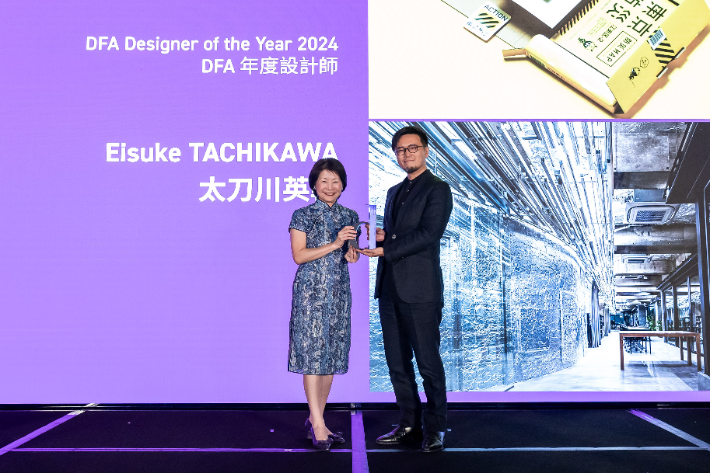 | Mr. Eisuke TACHIKAWA (right) receiving the title of DFA Designer of the Year 2024  Guest Presenter:  Ms. SUM Fong Kwang, Vivian, JP, Permanent Secretary for Culture, Sports and Tourism of the HKSAR
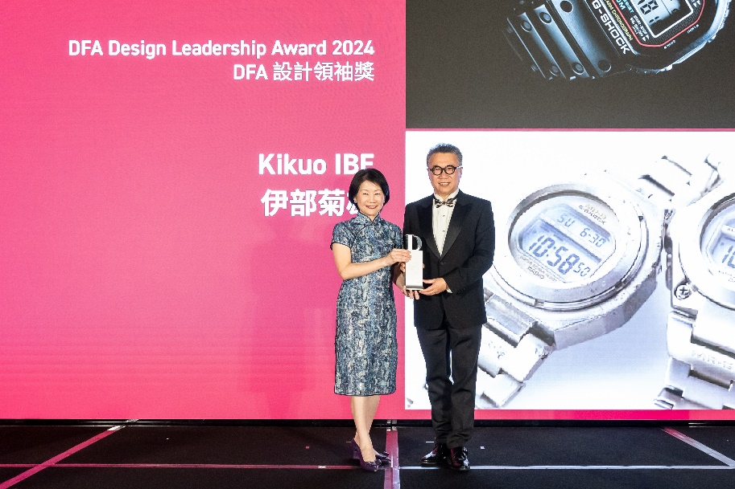 | Prof. Eric YIM, Chairman of Hong Kong Design Centre (right) receiving the title of DFA Design Leadership Award 2024 on behalf of Mr. Kikuo IBE  Guest Presenter:  Ms. SUM Fong Kwang, Vivian, JP, Permanent Secretary for Culture, Sports and Tourism of the HKSAR
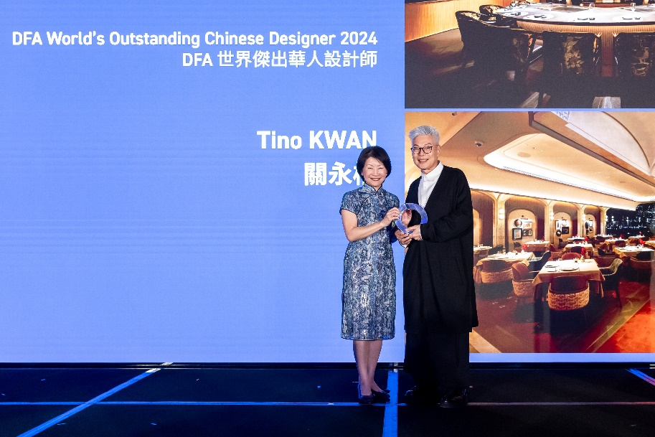 | Mr. Tino KWAN (right) receiving the title of DFA World’s Outstanding Chinese Designer 2024  Guest Presenter:  Ms. SUM Fong Kwang, Vivian, JP, Permanent Secretary for Culture, Sports and Tourism of the HKSAR
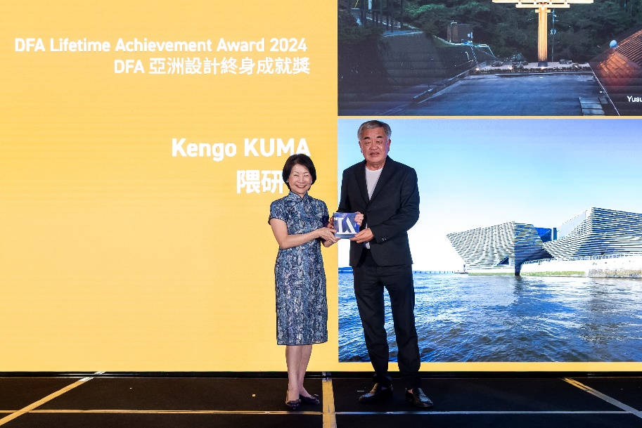 | Mr. Kengo KUMA (right) receiving the DFA Lifetime Achievement Award 2024  Guest Presenter:  Ms. SUM Fong Kwang, Vivian, JP, Permanent Secretary for Culture, Sports and Tourism of the HKSAR
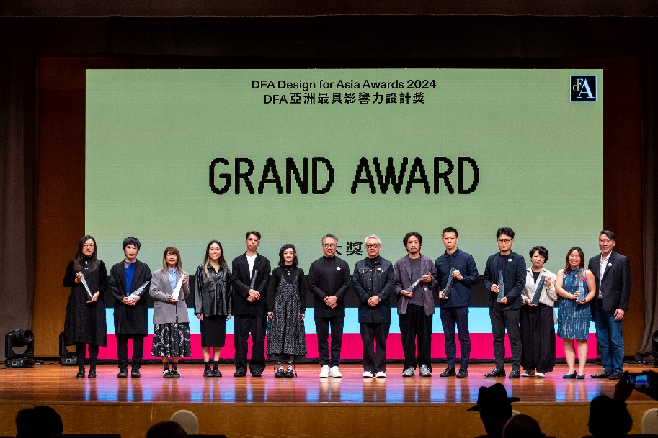 | DFA Design for Asia Awards 2024 - Grand Award winners with award presenters Professor Eric YIM, Chairman of Hong Kong Design Centre (7th from left) and Mr. Steve LEUNG, Vice Chairman of Hong Kong Design Centre (7th from right)
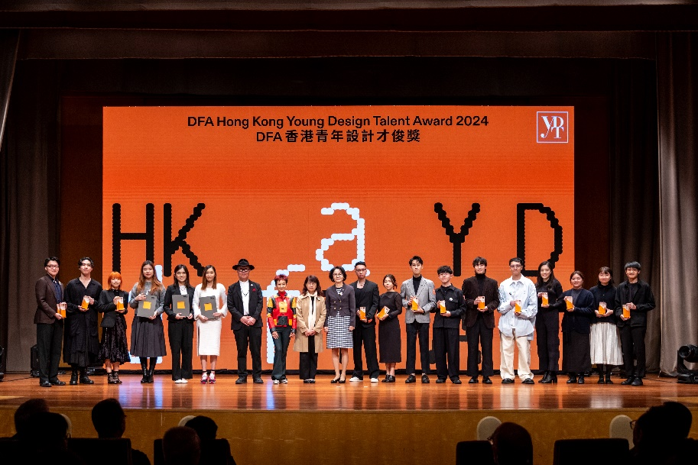 | DFA Hong Kong Young Design Talent Award 2024 winners with Guest of Honour Mrs Lowell CHO, Assistant Commissioner for Cultural and Creative Industries, Cultural and Creative Industries Development Agency (9th from left), and award presenters Professor Viveca CHAN, Vice Chairman of Hong Kong Design Centre (8th from left), Professor Kun-pyo LEE, Dean, School of Design, The Hong Kong Polytechnic University (7th from left) and Dr Lay Lian ONG, Principal, Hong Kong Design Institute (10th from left)
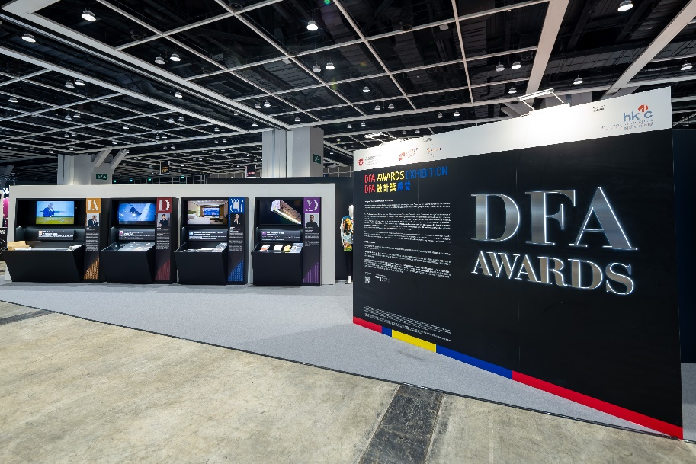 | DFA Awards 2024 Exhibition
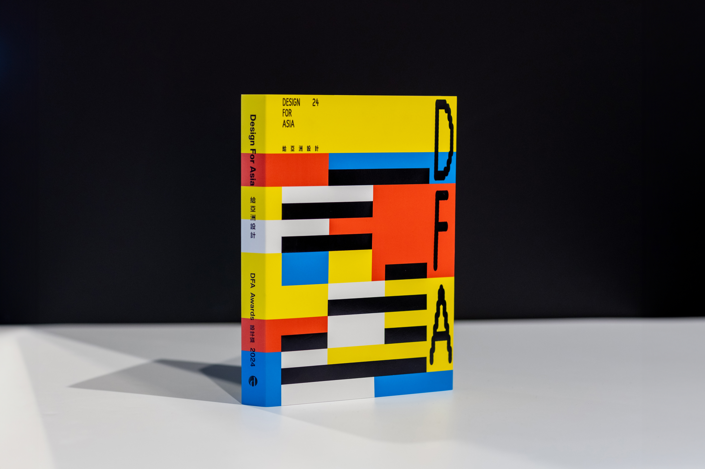 | The Awards Publication - Design for Asia: DFA Awards 2024

Please download the DFA Awards 2024 Event Review Press Kit and high-resolution images at:
DFA Awards 2024 Event Review – Press Kit

About DFA Awards (http://www.dfaawards.com)
Since 2003, the Hong Kong Design Centre has launched the DFA Awards to underpin the role of designers in society, to celebrate design leadership and exemplary designs and projects with commercial success or impact in Asia, as well as to recognise the rising force of emerging designers in Hong Kong. The DFA Awards, through its six major award programmes, has grown in its international influence in Asia.

About Hong Kong Design Centre (http://www.hkdesigncentre.org)
Hong Kong Design Centre is a strategic partner of the Hong Kong SAR Government in leveraging the city’s East-meets-West advantage to create value from design.
To achieve our goals, we:
• Cultivate a design culture
• Bridge stakeholders to opportunities that unleash the value of design
• Promote excellence in various design disciplines

About Cultural and Creative Industries Development Agency (https://www.ccidahk.gov.hk)
The Cultural and Creative Industries Development Agency (CCIDA) established in June 2024, formerly known as Create Hong Kong (CreateHK), is a dedicated office set up by the Government of the Hong Kong Special Administrative Region under the Culture, Sports and Tourism Bureau to provide one-stop services and support to the cultural and creative industries with a mission to foster a conducive environment in Hong Kong to facilitate the development of arts, culture and creative sectors as industries. Its strategic foci are nurturing talent and facilitating start-ups, exploring markets, promoting cross-sectoral and cross-genre collaboration, promoting the development of arts, culture and creative sectors as industries under the industry-oriented principle, and promoting Hong Kong as Asia’s creative capital and fostering a creative atmosphere in the community to implement Hong Kong’s positioning as the East-meets-West centre for international cultural exchange under the National 14th Five-Year Plan.

－END－

For media inquiries, please contact：

PR Agency’s Contact
RSVP Communications Ltd
Yuki Chan | yukichan@rsvp.com.hk | +852 2341 6177 / 6206 5233
Yuri Yu | yuri@rsvp.com.hk | +852 2341 6886 / 6479 5309
Hong Kong Design Centre
Chelsea Chan | chelsea.chan@hkdesigncentre.org | +852 3793 8455
Ivan Kwok | ivan.kwok@hkdesigncentre.org | +852 3793 8445

Disclaimer: The Cultural and Creative Industries Development Agency of the Government of the Hong Kong Special Administrative Region provides funding support to the project only, and does not otherwise take part in the project. Any opinions, findings, conclusions or recommendations expressed in these materials/events (or by members of the project team) are those of the project organisers only and do not reflect the views of the Government of the Hong Kong Special Administrative Region, the Culture, Sports and Tourism Bureau, the Cultural and Creative Industries Development Agency, the CreateSmart Initiative Secretariat or the CreateSmart Initiative Vetting Committee.

